Russian Facebook Propaganda Analysis Proposal

Donald Cooper, Paul Franklin, Jan Danel, and Tiger Hu

2/28/2020

On February 16, 2018 Special Counsel Robert S. Mueller III indicted 13 Russian individuals and three Russian organizations for engaging in operations to interfere with U.S. political and electoral processes, including the 2016 presidential election. This was a significant step forward in exposing a surreptitious social media campaign and holding accountable those responsible for this attack. The indictment spells out in exhaustive detail the breadth and systematic nature of this conspiracy, dating back to 2014, as well as the multiple ways in which Russian actors misused online platforms to carry out their clandestine operations.

**Methodology**

Our primary research question involves the efficacy of advertisements by the Russian “Troll” farm that targeted the American public through social media platforms. Further, we want to observe how effective the ads were as a political weapon leading up to the 2016 General Elections. Factors that could potentially help answer this question are whether voting patterns changed due to the Russian propaganda. In order to analyze a change in voting patterns, we did a comparison from the election cycles during both 2016 and 2012 using the latter as the control group for the study. We also considered taking into account a few of the past presidential elections to build a time-series analysis. Considerations were also made as to whether data should be gathered on whether the IRA chose to create advertisements in prior years before the 2016 elections (i.e. our control year of 2012) as another baseline of comparison for ad effectiveness.

The supporting literature provides evidence that Russians targeted unregistered U.S. Citizens after the election. However, the literature did not seem to have evidence to whether the advertisements had any effect on unregistered U.S. Citizens before the election. Our model is intended to give an estimate on how effective the advertisements were on unregistered citizens and whether the ads provoked a significant percentage change in registered voters from unregistered voters from 2012 to 2016 (see Spangher p8). In addition to testing the effectiveness of the advertisement, we wanted to measure the effectiveness by location, preferably at the city or state level. (Exactly what Dutt did but within geological location): predicting ad efficacy in particular cities/states with ad language. Could run a bunch of Wilcox’s and bonferroni adjust or bag)

**Data Collection Methods**

The data we selected to use was the same data collected and used during the The House Intelligence Committee Minority Investigation by Special Counsel Robert S. Mueller who indicted 13 Russian individuals and three Russian organizations, including the IRA, for engaging in operations to interfere with U.S. political and electoral processes, including the 2016 presidential election. As part of the Committee’s open hearing with social media companies in November 2017, including the hearing with Founder and CEO of Facebook Mark Zuckerburg, the Minority used a number of advertisements as exhibits, and made others available as part of a small representative sampling. During the hearing, Committee Members noted the breadth of activity by the IRA on Facebook. Facebook released that “a total 3,519 total advertisements were identified to have been purchased” with over “11.4 million American users exposed to those advertisements”. This included 470 IRA-created Facebook pages and 80,000 pieces of organic content created by those pages. The exposure of organic content by these pages was estimated to have reached “more than 126 million Americans”. These Facebook advertisements have already been carefully reviewed by the Committee Minority Investigation and redacted by Facebook to protect personally-identifiable information (PII). The data made available by the Committee Minority does not include the 80,000 pieces of organic content shared on Facebook by the IRA, but the House Intelligence Committee Minority has mentioned this material may be made available in the future which would likely warrant further analysis. In addition to the 3,519 advertisements made public by the House Intelligence Committee Minority, we have also gathered data from the U.S. Census Bureau and the U.S. Bureau of Labor Statistics that mostly has to do with demographics, voting statistics, and median household income measured by state. This additional data was selected by states in order to combine this data with the Facebook Ad data which we decided to break down to state-level, as we will explain.

**Analysis Methods**

For the analysis, we needed to measure the effectiveness of ads on a particular location or population level. In other words, we needed a variable that we could use to differentiate the effectiveness from sample to sample. While the level could be any location parameter, such as town or city, we opted to use a state level location parameter because of the abundance of data available through government websites such as the Census Bureau, Bureau of Labor Statistics, etc. Advertisements would then be categorized by the locations they targeted. We cleaned the data to include the states in which the ads targeted from their general location IDs which varied in nature. Some included only the state while others needed to be split from other coded values, such as having a city coded in next to the state name which identified that the ad targeted a particular city within that state. There were 982 entries that included a state level characteristic where an ad appeared. Others that were either from a different country or did not contain any location were removed from the dataset. Some ads happened to have multiple states that they had targeted. To account for columns with two or more state values on ad count, the states were separated and advertisement IDs were counted the number of times it was included within a different state.

In addition to identifying which ad appeared in which state, a method needed to be developed in order to test the advertisement efficacy within each state individually for comparative purposes. For each state, a dummy variable was created to account for each location in which an ad had appeared. For the purposes of our model, the state dummy variable would account for when a specific ad had appeared or not for that respective state[1].

Chart 1: Example of the role of the state dummy

variable in model regression.

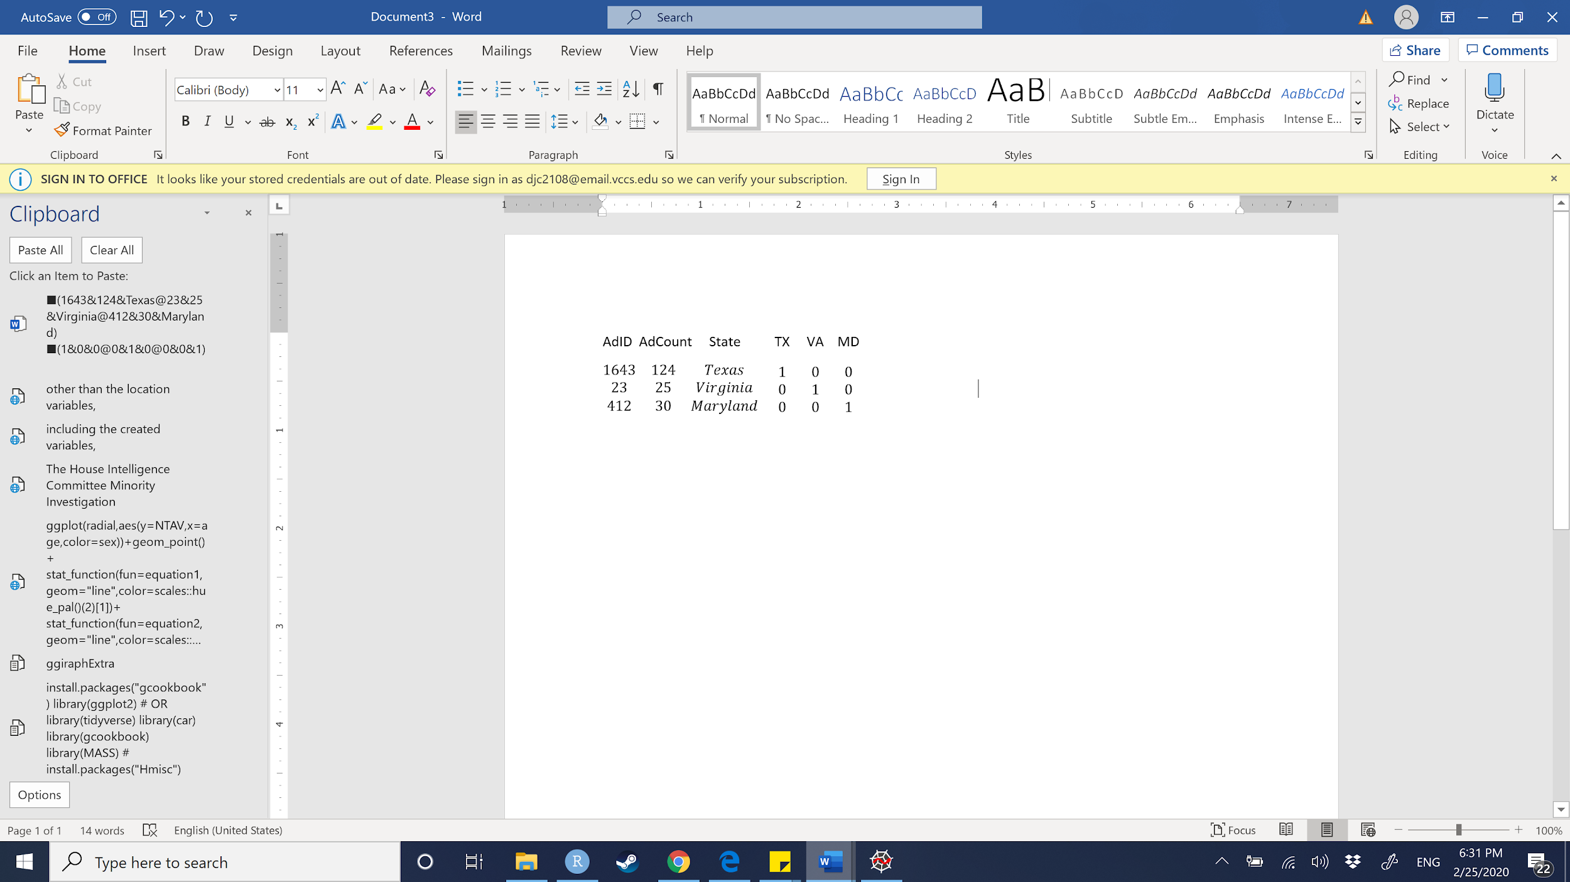

Many of the variables that were needed were created through coding the original Russian Ad Dataset, many of the variables were also kept. The original variables we included were Clicks, or the number of clicks that Ad had received, and Impressions, “anytime the ad appeared on someone’s Facebook feed for the first time” (FB). The creation date as well as the end date of the ad were kept in the dataset. For the advertisements that did not include an end date, we decided to add the end date of the ad as the date when the House Intelligence Committee Minority asked Facebook for the data. The count of each advertisement, as well as the cost for each ad, was included for each reported ad ID. The text for each advertisement was also included. We created our response variable out of dividing the amount of clicks over the number of impressions for a click-through-rate (CTR). The CTR is the amount of clicks each ad had received in respect to the number of impressions it had garnered. From both the creation and end date, we created a duration variable that gave the time in which the advertisement was active in days. From the ad text variable, we created an ad word count (AdWordCount) variable to count the number of words of that particular ad. Other than the location variables, all of the original data, including the created variables, were quantitative variables. In addition to the original data, other outside data was gathered to boost the effectiveness of the analysis. State level data regarding voting statistics, demographics, and population data were merged with the current Russian Ad data. Most of the useful predictors from this gathered data were quantitative in nature.

It was discussed that using a fixed-effects regression model[2] was the best method for the analysis in examining the effectiveness of russian political propaganda. As discussed before,

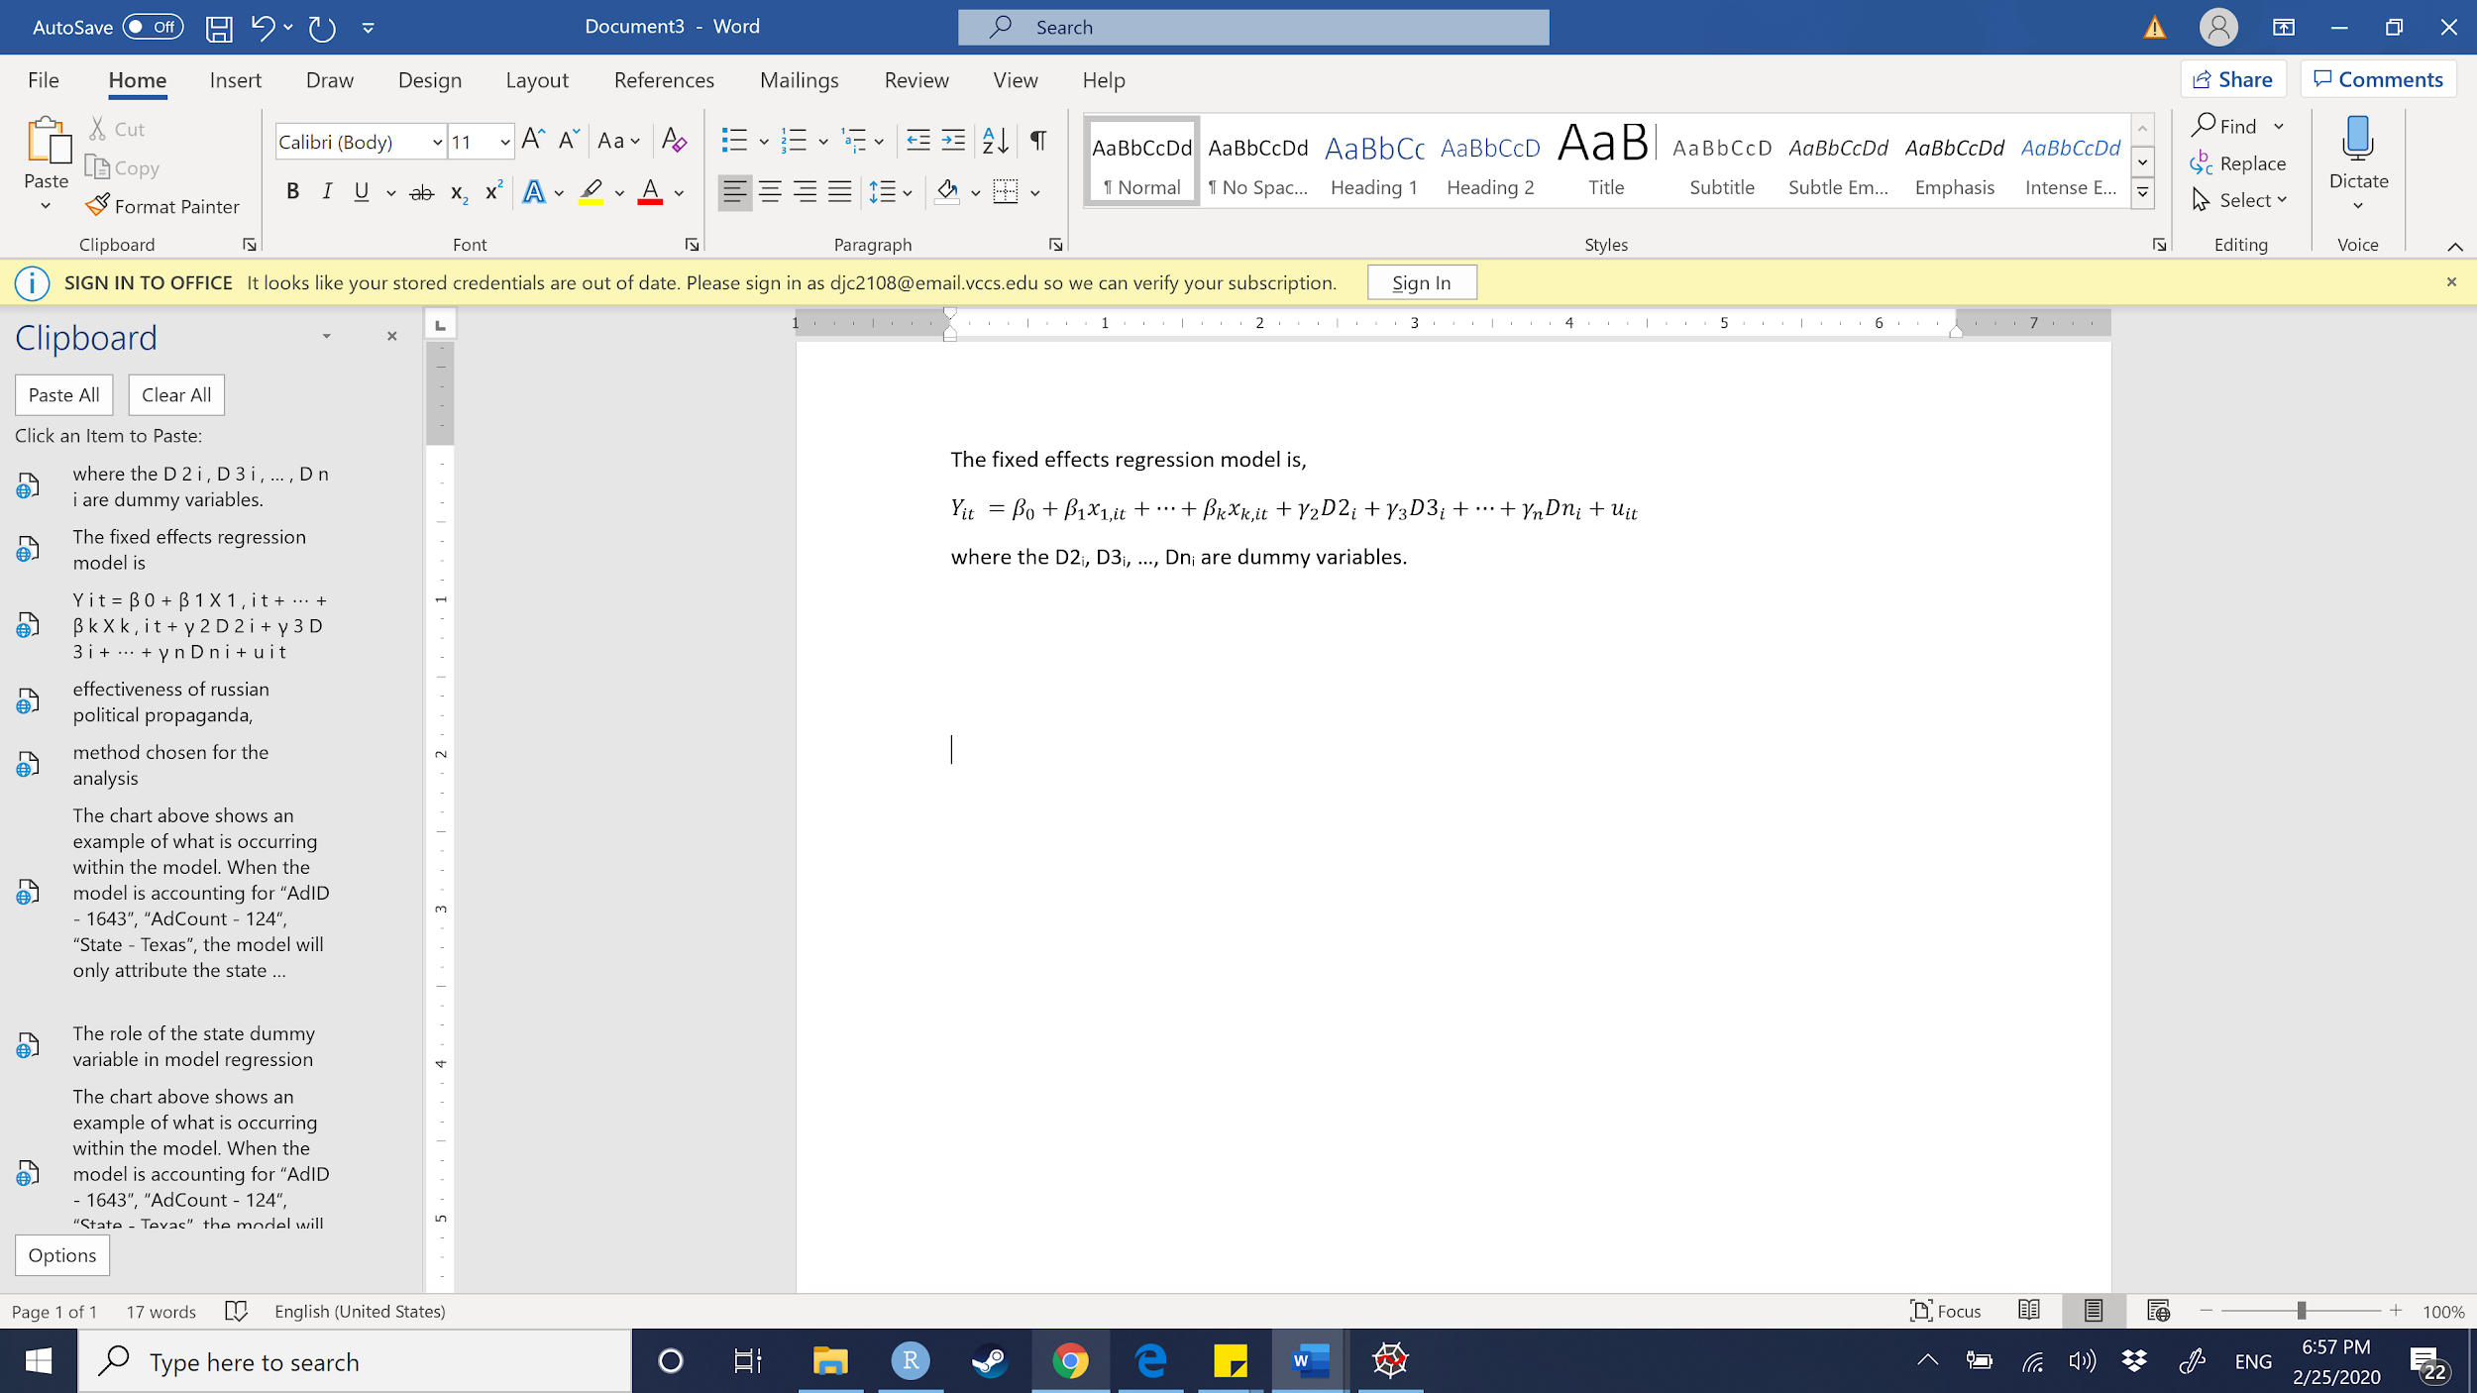

and will account for all states for individual comparison to a baseline. Currently, we have discussed using Maryland as the baseline for our fixed-effects regression because Maryland was targeted by the Russian Ads the most. Maryland had a total of 177 different facebook ads appear. Only three other states had over 100 different ads (i.e. Missouri, Ohio, New York). The remaining states had under 70 different ads appear. We concluded that using Maryland would offer a reasonable baseline for comparison because of the high concentration of ads. For example, a state could have been affected by ads more than Maryland or affected by ads less than Maryland based on the model prediction. Of course, we’ll attempt other adjustments and pursue new predictors if our model diagnostic plots show a violation of any one of the regression assumptions. If there is evidence of multicollinearity among our predictors, we will conduct a multi-fold cross validation to pick our tuning parameters for Ridge and Lasso regression. We also plan to conduct a Box-Cox transformation of the response in the event that our variance is nonconstant. We will do this before attempting to interpret any output. Further, stepwise regression has identified a few significant dummy variables. WordCount was an informative quantitative predictor, however we wish to identify a stronger foundational quantitative predictor. In the near future, we will compare these results to those of Garrote regression to observe whether bias adjustment changes our choice of predictors.

**Analysis Justification**

We believe a multiple regression fixed effects model to be the best algorithm for answering our research question. In particular, outside research has identified multiple variables that correlate with the effectiveness of russian political propaganda, yet not have tried to predict effectiveness by combining all of these variables into a model. We believe that given new data, such a model could accurately predict the effectiveness of any newly detected advertisements (given some reliable predictors). This way, public officials and social media sites can narrow their search to the most effective types of advertisements, and hopefully be more successful at eliminating it in the future. We are also inclined to use multiple regression because we know of several augmentation methods like Ridge, Lasso, and Stepwise regression to justify our choices of predictors.We also ruled out some nonparametric statistical methods like regression splines and smoothing splines. Other methods were not suitable given our objectives for the following reasons.

Since we had a response variable of interest from the beginning, we did not conduct Principal Component Analysis, which is unsupervised. This method would be informative if we wish to consider other response variables in the future, but given time constraints and our desire to discern which ads were most effective, we skipped PCA. Regression decision trees were ruled out as they are generally less accurate in predicting quantitative response variables than multiple linear regression. Still, for the future a tree could let us compare the importance of one of our IVs to every other IV. A regression decision tree would also be advantageous if we wanted an algorithm that would produce an easily interpretable tree diagram. Such a diagram would be a good visual if we’re fortunate enough to report our findings to the public. Likewise, we decided against a Log-Likelihood regression, as we have a quantitative response. In the future, we might also consider a hierarchical or K-means clustering technique to identify subgroups of people most susceptible to ads. This could also be a valuable way to narrow the search for propaganda in the future, as the IRA will most likely try to exploit those subgroups it successfully influenced in the time frame of our data.

Finally, in the event that we discover an auxiliary variable with a particularly strong proportional relationship, we could employ a synthetic or ratio estimation method to deduce a reasonable count of the number of clicks that occurred in each geographic location mentioned in our data. This has the potential to drastically increase our observation count, thereby improving the predictive capability of our model at the expense of unbiasedness. This notion is inspired by cluster sampling estimation, since we could consider the advertisements as our primary units, and their respective locations (New York, California, and Baltimore, MD for example) the secondary units. By this reasoning, if the size of the secondary units (measured in population) were proportional to the click count, we could estimate the number of clicks that appeared in each individual location (with some bias). We would then have to compare the sum of all these estimated clicks to the actual sum of clicks nationally to measure the magnitude of our bias. If successful, we would have a much better measure of which locations were most affected by the russian advertisements, and could warn people accordingly. This would be a much more intuitive interpretation than that of our current model, which would only state that the difference between the expected CTR of Baltimore and the expected CTR of the rest of the country is β-hat. Still, we would appreciate feedback on this hypothesis.

**Potential Objections**

A possible objection to how we manipulated our data would involve the end date of the advertisements that were unknown, and our assumption that they were taken down on the day that Facebook gave the House Committee the report. In other words, we assumed that the end date for all missing “end date” values was the last day Facebook compiled the ads before giving it to the House Committee.

Creating individual rows for a single row which had multiple locations in order to have Ad information by individual states could also be thought of as manufacturing points since we could be counting multiple variables more than once. A problem with this is that we have a certain number of clicks for a specific ad and we cannot assume homogeneity across the states. The way we addressed this problem was by creating the Click Through Rate of the ad which is a rate and thus should be the same across heterogeneous states.

In addition, not all of our regressions to date include ads that appeared nationally. These ads could have appeared in any of the states for which we have dummy variables, but we’re unable to train the dummies on those clicks since we do not know where clicks of a national-level ad occurred locally. In this way, our dummy variables may not represent the true change in effectiveness when a state is targeted.

Finally, for comparing the effectiveness of the Russian Facebook ads, we wanted to gather data that was either not political or simply generic ad data from facebook between the years of 2015 and 2017. Unfortunately, Facebook does not publish ad statistics from before May of 2018. Thus, we could not get an accurate date range for ads during this period that were not from the IRA. We have decided to use ad statistics from May 2018 to May 2019 and calculate the effectiveness of these ads to compare with the 2015 and 2017. This was the closest date range of ads we could find to use as a control group.

1. Chart 1 on the following page shows an example of what is occurring within the model. When the model is accounting for variables “AdID” = 1643, “AdCount” =124, “State” = Texas, the model will only attribute the state dummy created for Texas (i.e. TX in the model) with “AdID” = 1643, “AdCount” = 124, and “State” = Texas. This works for all other states.
2. Having individual specific intercepts *𝛂i*, *i = 1,...,n,* where each of these can be understood as the fixed effect of entity *i,* the model will have fixed effects on the response variable. For the formula above, *𝛂i* are entity-specific intercepts that capture heterogeneities across entities and are denoted as 𝜸*nDni* (Econometrics with R, 10.3).